Table of Contents

Introduction 1
KSF 2
Hints and Tips for Reviewers 2
eKSF 3
Guide to your Manager homepage 3
Assigning Outlines to Multiple Staff 6
Assigning Reviewers to staff 7
Helpful information held in e-KSF for Managers 8
Delegating Secretary Access Rights 9
Guide to your Reviewer homepage 10
Using the “Complete on Paper” option 13
Guide to your Staff homepage 14
Hints and Tips on using e-KSF 17
e-KSF Troubleshooting FAQ’s 18
Case Studies 19
NHS Fife Case Study 19
NHS Grampian Case Study 20
NHS Greater Glasgow & Clyde Case Study 28
NHS Shetland Case Study 44

Introduction
Keep it Simple and Flexible Good Practice Resource

The NHS KSF is a key part of the Agenda for Change pay system. It applies to all staff employed on Agenda for Change terms and conditions. It is an organisational tool for describing the knowledge and skills that staff need to apply at work in order to deliver high quality health care services.
The KSF can be embedded simply and flexibly through good partnership working arrangements.
This resource aims to provide managers and reviewers with useful hints and tips around using the e-KSF, on the review process and gathering evidence.
Also included are a number of case studies which support the sharing of good practice around implementation of KSF. In particular, the NHS Greater Glasgow and Clyde case study outlines useful tips on recording appropriate evidence and the NHS Grampian study outlines their approach to implementing KSF successfully for facilities staff.
We hope you will find this a helpful guide and reference source.
Anne Campbell
KSF Implementation Lead
NHS Scotland

Members of the Keep it Simple and Flexible Good Practice Resource sub group

Name | Job title | Board
Aileen Campbell | KSF Administrator/Coordinator | NHS Ayrshire & Arran
Anne Campbell | KSF Implementation Lead | NHS Scotland
Helen Cheyne | KSF Project Manager | NHS Grampian
Anne-Marie Greene | Project Officer (KSF/e-KSF)/ Lead e-KSF Administrator | NHS Scotland
June Livingstone | KSF Manager | NHS Greater Glasgow & Clyde
Jackie Millen | Training Coordinator/e-KSF Trainer | NHS Fife
Evelyn O’Neil | KSF Manager | NHS Fife
Heather Stuart | KSF Coordinator | NHS Grampian

KSF

Hints and Tips for Reviewers

REMEMBER – the important part of development review is the conversation between reviewer and reviewee.

Give you and your staff ‘permission’ to be learners. The process is new to everyone.

The Review Process

- Set aside a reasonable time-slot for the review discussion and stick to that time – don’t allow the discussion to run on.
- Plan the key points of what you want to say in advance – think about how you will say it and why you need to say it. Write down the key points.
- Agree in advance with the reviewee which dimensions you will cover in the discussion – you don’t have to cover all dimensions in every review discussion.

Gathering Evidence

Use what is already there for evidence – for example

- have your staff completed SVQ’s? – the evidence provided for assessment is also relevant for KSF
- facilities/estates staff workbook – completion of these workbooks provides evidence for level 1 indicators for core dimensions.
There is no need for a ‘paper chase’ or maintenance of portfolios – all of the evidence should be available naturally in the workplace and can include verbal feedback or observation of practice in the workplace.

REMEMBER one piece of evidence may be suitable for a number of indicators and/or dimensions and only a summary of the evidence needs to be recorded on e-ksf.

Further help and guidance on what constitutes appropriate evidence is available from your local KSF team.

e-KSF

Guide to your Manager homepage
Your Manager homepage has various different options/icons to select and the purpose of this guide is to explain what each of these are for. When you open your Manager homepage you will see the following window:

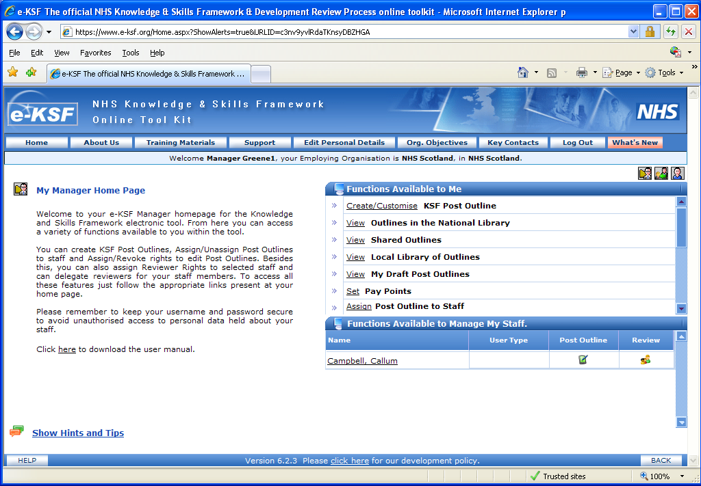

The buttons highlighted above always appear at the top of the screen no matter which option you select within your Manager homepage. The buttons that are relevant to you are described below:
- Home – this button does as it says and will return you to your Manager homepage at anytime if you become unsure as to how to proceed.
- Edit Personal Details – clicking on this button opens a window where you can change your password, update your login name or reset your secret question and answer.
- Org. objectives – this button opens a window that would detail the objectives for your organisation. Please note that objectives will only show if they have been populated by your e-KSF Administrator.
- Key contacts – this window shows the contact details for your local e-KSF Administrator(s). Their details show under ‘Employing Organisation Admin’.
- Log out – when you wish to exit from e-KSF you would click on this button.

The ‘Functions Available to Me’ section on your Manager homepage allows you access to:
- creating post outlines
- post outline libraries
- any draft post outlines that you are working on
- assigning/unassigning post outlines to your staff
- giving staff reviewer rights
- reports
- assigning/revoking rights to edit post outlines
- viewing any post outlines that have been delegated to you by another user
- delegating your access to a secretary (if applicable)

In addition to the above options there are also additional options available to you in the ‘Functions Available to Manage My Staff’ (as shown below) to manage the KSF processes for your staff. Please note that if no post outline has been assigned to a staff member there will be no icons showing for your staff.

Each function is explained below:
- Name: details the name of the staff member.
- User type: the word ‘Practice’ may appear in this box if you have been assigned a practice user account for training purposes.
- Post Outline: clicking on this icon opens up a separate window which shows the post outline history for the staff member and the option to assign a reviewer to the staff member.
- Review: clicking on this icon opens up a separate window which allows you ‘view only’ access to review documents for a staff member.

Some ‘hints and tips’ for using e-KSF are shown on the next page.

Hints and Tips
- e-KSF is a database that can be accessed anywhere that an internet connection is available. It can only be accessed using Internet Explorer.
- When you are assigning a post outline to a group of staff using the ‘Assign Post Outlines to Multiple Staff’ option then you can enter a wildcard (‘%’) into the search box for first name and this will list the details of your staff instead of having to search for each individual person.
- No matter what level of access you have for e-KSF if there is any underlined text showing on the screen you can click on this and it is a link to further information. For example the link to a review or objectives document is underlined.
- If any updates are made to e-KSF you can click on the pink ‘What’s new’ button at the top of your screen and this will list the details of the updates made.
- The ‘Edit Personal details’ button at the top of your screen opens a pop up window which allows you to view your personal information that has been received from SWISS; you can update your email address and phone numbers; you can reset your secret question and answer plus your login name; you can also change your password through this window.

Your local e-KSF Administrator will be able to provide you with further information on using the options available on your Manager homepage.

Assigning Outlines to Multiple Staff

The majority of post outlines developed within each Board will relate to more than one member of staff and it can be time consuming assigning to each individual member of staff. However, it is now possible to assign an outline to more than one member of staff using the ‘Assign Outlines to Multiple Staff’ option on your Manager homepage as highlighted below:

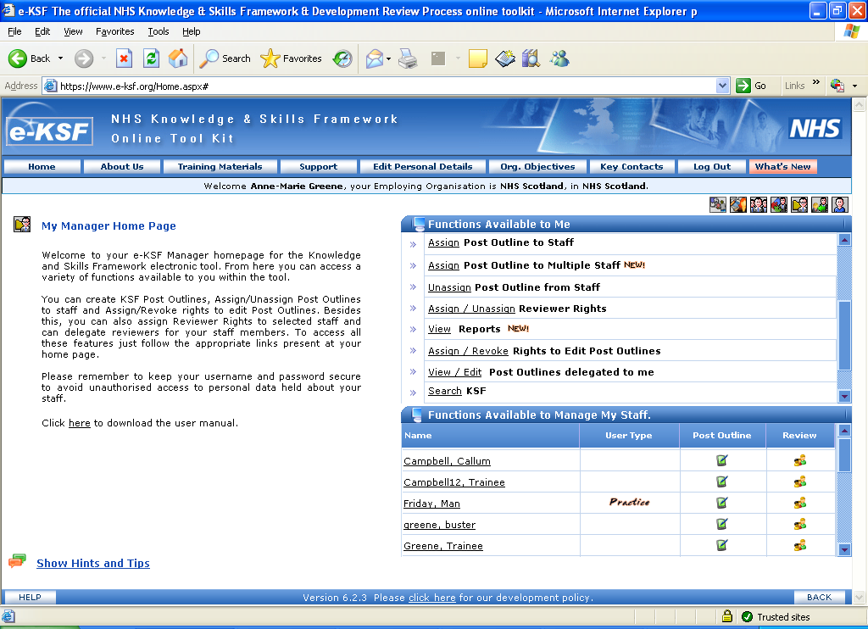

After clicking on this option you will first of all need to select the correct post outline and then you would search for the staff that the outline is to be assigned to.

Your local e-KSF Administrator will be able to provide you with further information on using this option and how to then assign reviewers to your staff.

Assigning Reviewers to staff

As an e-KSF Manager you may manage a large number of staff and need assistance with carrying out the KSF processes in e-KSF for all of your staff. To allow selected members of your staff to assist you they need to first of all be given the right to be a Reviewer i.e. they have the Reviewer page in e-KSF. Once they have this you would assign them to the staff that they will be reviewing on your behalf.

Please note that once you have assigned a Reviewer to staff these staff will still show in your list of staff on your Manager homepage but when you access your Reviewer page they will no longer be visible to you because you have assigned someone else to review them.

To assign/unassign reviewer rights for your selected staff you need to click on the “Assign/Unassign Reviewer Rights” option on your Manager homepage as shown below:
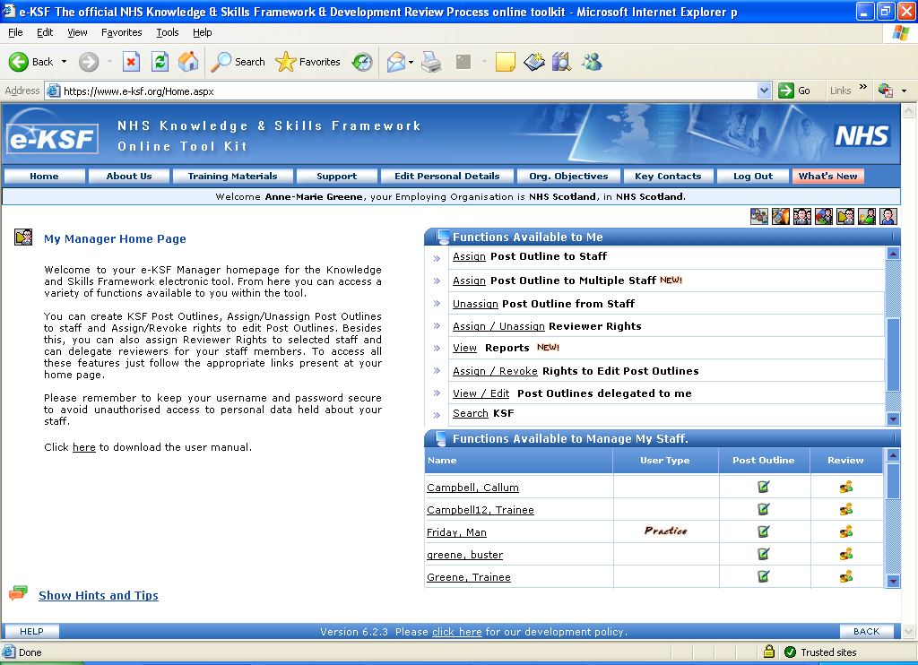

Your local e-KSF Administrator will be able to provide you with further information on using this option and how to then assign reviewers to your staff.

Helpful information held in e-KSF for Managers
As a Manager it is possible for you to run reports for the staff that you manage and these reports can be found via the ‘View Reports’ option on your Manager homepage. After clicking on the link you will see the following window:
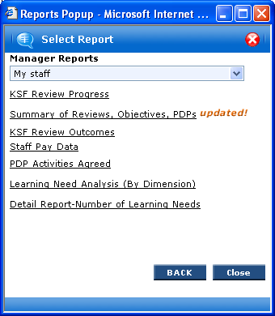
The drop down menu at the top of this window provides you with two option in relation to who you can produce reports for and these options are:
- My staff – when selecting this option the reports will be based upon those staff that you directly manage
- All staff within my line management structure – if you manage staff who then in turn also directly manage staff it is possible for you to produce reports on all of the staff who are within your line management structure
After selecting the basis for your reports the type of information that you will be able to view is:
- Post outline assigned
- Reviewer name
- Current pay band, pay point and incremental date
- Progress on whether a review has taken place, PDP activities have been agreed and objectives have been set (if applicable)
- Review outcomes i.e. current level against assigned post outline
- Whether a Second Gateway review is due during the next 12 months
- PDP activities agreed and this can also then be broken down based upon each KSF dimension.
If you need any further information on the Manager reports available to you please contact your local e-KSF Administrator.

Delegating Secretary Access Rights

As a Manager you can delegate secretary access rights to a staff member. By giving this right to staff, you allow a user (your secretary/PA) to access your Manager and Reviewer options which will then allow them to update e-KSF on your behalf.
Please note that if you delegate secretary access you would only be able to view the options/information for your staff. It is not possible for you to add/update any information without removing secretary access rights from the person you have delegated them to.
You can only delegate rights to one staff member at a time. You can also withdraw this right from staff at any time. To access this feature, just click the highlighted “Delegate Secretary Access Rights” link (as shown below) from your home page:
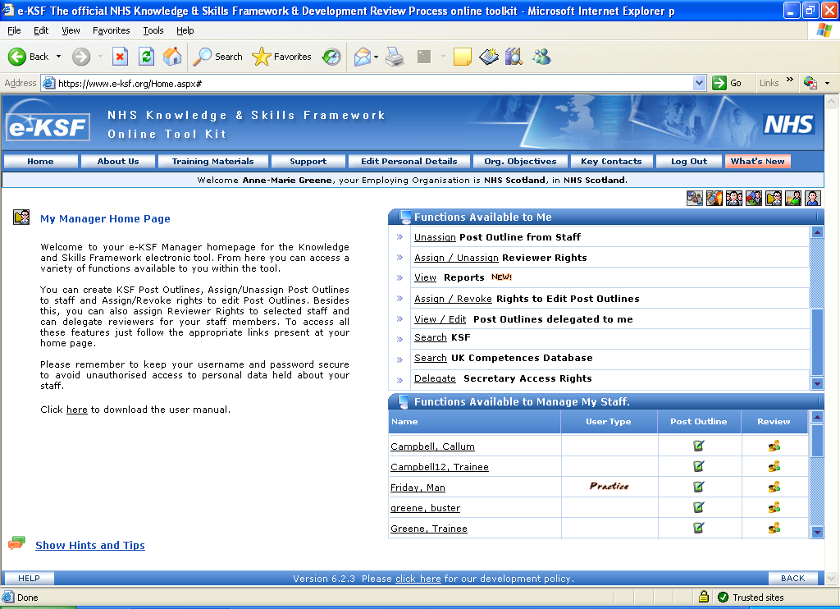
Please note that this option will only appear if the decision has been made locally at your organisation to ‘Enable’ this facility from the e-KSF Administrator’s homepage.
Your local e-KSF Administrator will be able to provide you with further information on using this option.

Guide to your Reviewer homepage
Your Reviewer homepage has various different options/icons to select and the purpose of this guide is to explain what each of these are for. When you open your Reviewer homepage you will see the following window:
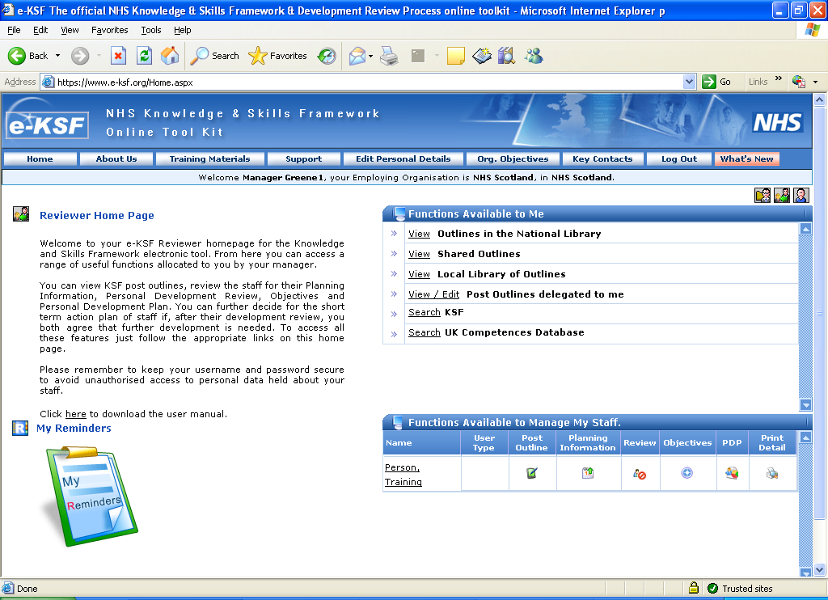
The buttons highlighted above always appear at the top of the screen no matter which option you select within your Reviewer homepage. The buttons that are relevant to you are described below:
- Home – this button does as it says and will return you to your Reviewer homepage at anytime if you become unsure as to how to proceed.
- Edit Personal Details – clicking on this button opens a window where you can change your password, update your login name or reset your secret question and answer.
- Org. objectives – this button opens a window that would detail the objectives for your organisation. Please note that objectives will only show if they have been populated by your e-KSF Administrator.
- Key contacts – this window shows the contact details for your local e-KSF Administrator(s). Their details show under ‘Employing Organisation Admin’.
- Log out – when you wish to exit from e-KSF you would click on this button.
The ‘Functions Available to Me’ section on your Reviewer homepage allows you access to post outline libraries and also to any outlines that have been delegated to you by another user.
You will mainly use the options under ‘Functions Available to Manage My Staff’ (as shown below) to manage the KSF processes for the staff that you are reviewing. Please note that if no post outline has been assigned to a staff member the only icons that will be available to you are those for objectives and PDP’s.

Each function is explained below:
- Name: details the name of the staff member.
- User type: the word ‘Practice’ may appear in this box if you have been assigned a practice user account for training purposes.
- Post Outline: clicking on this icon opens up a separate window which shows the post outline history for the staff member.
- Planning Information: clicking on this icon changes the window to allow you to enter dates in relation to the review period, date review and PDP creation will take place and when progress against the PDP will be discussed.
- Review: clicking on this icon opens up a separate window for you to open or select an existing review document. This icon changes appearance during the review process as follows:
- The icon with the red ‘wheel’ details that no review has been started
- The icon with a green ‘wheel’ details that a document has been started
- The icon with a tick and clock details that a review has been signed off
- The icon with an exclamation mark (!) details that the last review took place more than 12 months ago.

- Objectives: clicking on this icon opens up a separate window for you to open or select an existing objective document.
- PDP: clicking on this icon takes you to the PDP page where you can add new PDP activities or update any existing activities.
- Print details: clicking on this icon opens up a separate window which provides a list of documents that are available for you to print for the staff member.
The final section on your Reviewer homepage is the My Reminders area and if you click on the clipboard (shown below) it will open a new window showing calendar dates:
The current date will show highlighted in blue and any other dates highlighted in pink are dates that you may have entered for staff into the Planning Information section. Please note that the calendar shows the dates for the previous 3 months and the next 15 months making an 18 month period in total.
Please note that when entering any data into e-KSF through your Reviewer page you should always save the data using the relevant ‘Save’ buttons. If you click on ‘Cancel’ any data that you have entered will not be saved.
However, when you are in a review document it does have a small auto save facility where the current levels that you enter will automatically be saved so you do not need to click on ‘Save’ at the bottom of the document.

Hints and tips on using e-KSF
- e-KSF is a database that can be accessed anywhere that an internet connection is available. It can only be accessed using Internet Explorer.
- e-KSF is the tool for recording the outcome of discussions on the KSF processes between staff and their Manager/Reviewer. When recording the detail keep it simple by only recording the highlights of the discussion.
- It is not possible to record a review if a post outline has not been assigned to a staff member in e-KSF.
- The evidence window within a review document has a minimum number of characters that must be entered and this number is 3. The maximum is 8,000.
- Once a PDP activity has been completed it is possible to link this to the relevant dimension via the evidence window in an editable review document.
- It is possible for Reviewers and staff to upload files to Reviews and PDP’s. There is a 1MB limit per Review and the same limit covering all PDP activities.
- No matter what level of access you have for e-KSF if there is any underlined text showing on the screen you can click on this and it is a link to further information. For example the link to a review or objectives document is underlined.
- If any updates are made to e-KSF you can click on the pink ‘What’s new’ button at the top of your screen and this will list the details of the updates made.
- The ‘Edit Personal details’ button at the top of your screen opens a pop up window which allows you to view your personal information that has been received from SWISS; you can update your email address and phone numbers; you can reset your secret question and answer plus your login name; you can also change your password through this window.
Your local e-KSF Administrator will be able to provide you with further information on using the options available on your Reviewer homepage.

Using the “Complete on Paper” option
The e-KSF allows you to record that a review has been completed on paper. This can only be done if the option to record a review completed on paper has been activated by the e-KSF Administrator for your organisation. If it has been activated it is only possible to record the review through your Reviewer homepage. You as the Reviewer only need to enter the current levels agreed at the review together with the actual date that the review took place on.
To record the outputs of a review that has been completed on paper you follow the same processes as recording a review that has not been completed on paper. The difference that you will see is that at the bottom of the review page there will be a radial box with the wording ‘Individual is completing this process on paper’ as shown below:

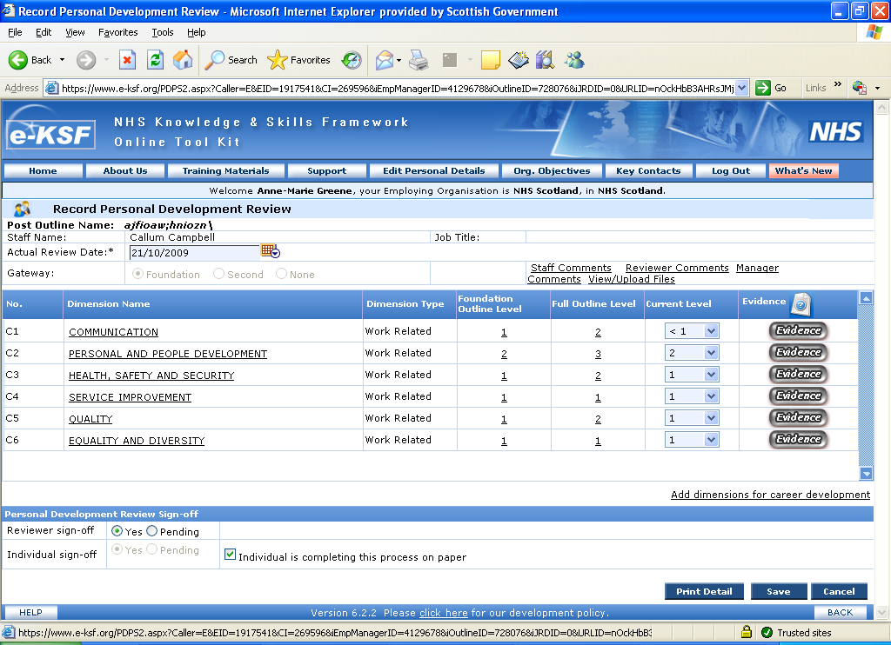

Clicking in the radial box informs e-KSF that the review has already been completed on paper and that no evidence detail needs to be entered into the review.
Your local e-KSF Administrator will be able to provide you with further information on using this option.

Guide to your Staff homepage
Your own personal Staff homepage has two different layouts that you can select and the purpose of this guide is to explain what each of these are.

When you first open your Staff homepage it will be appear as shown in the following window:
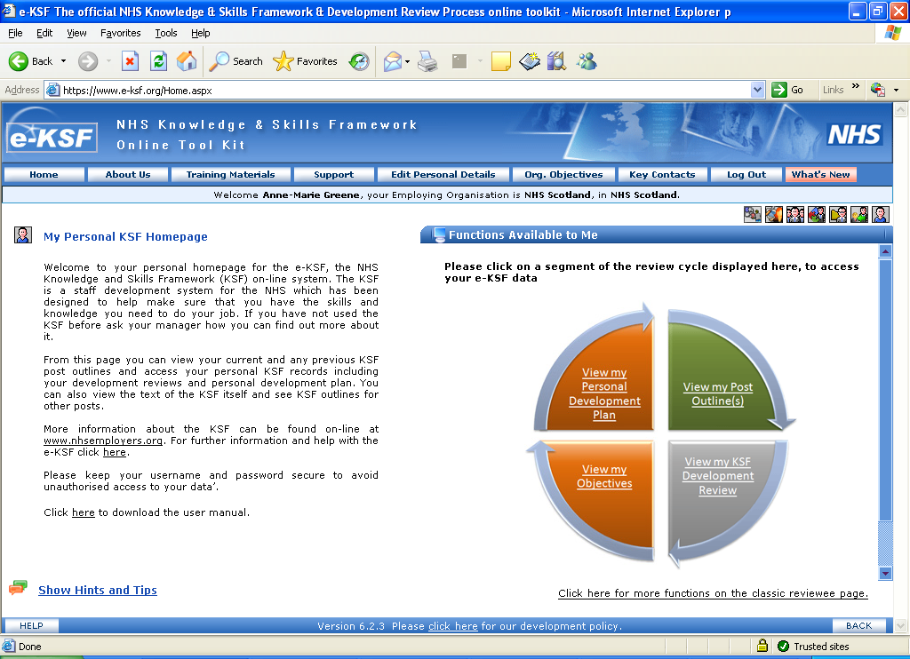
The buttons highlighted above always appear at the top of the screen no matter which option you select within your Reviewer homepage. The buttons that are relevant to you are described below:
- Home – this button does as it says and will return you to your Reviewer homepage at anytime if you become unsure as to how to proceed.
- Edit Personal Details – clicking on this button opens a window where you can change your password, update your login name or reset your secret question and answer.
- Org. objectives – this button opens a window that would detail the objectives for your organisation. Please note that objectives will only show if they have been populated by your e-KSF Administrator.
- Key contacts – this window shows the contact details for your local e-KSF Administrator(s). Their details show under ‘Employing Organisation Admin’.
- Log out – when you wish to exit from e-KSF you would click on this button.
The layout shown in the previous window is known as the ‘new reviewee page’ and it shows a review cycle with segments that can be clicked on to take you into the following options:
- View my Personal Development Plan: clicking on this segment takes you into your Personal Development Plan (PDP) page.
- View my Post Outline(s): clicking on this segment opens a pop up window that shows the current outline that is assigned to you together with a history of all post outlines that have previously been assigned to you.
- View my KSF Development Review: clicking on this segment opens a pop up window where you can create a new review document or open an existing review document. Please note that it is not possible to record a review if a post outline has not been assigned to you in e-KSF.
- View my Objectives: if objectives apply to you clicking on this segment opens a pop up window where you can create a new objective document or open an existing objective document.
An additional element to these segments is that they change colour as updates are made to them. The colours and what they mean are detailed below:
- Grey – there is nothing recorded in e-KSF
- Orange – an editable review, objective or PDP activity is recorded but it has not yet been signed off
- Green – as per orange and the documents/activities are now signed off and agreed with your Reviewer. This colour also applies when an outline has been assigned to you.
- Yellow – this colour will only appear in relation to a review, objectives or PDP that was recorded more than 12 months ago in e-KSF.
There are some additional options available to you but they can only be accessed if you select for your homepage to be shown as ‘classic reviewee’. To access these you need to click on the link titled ‘click here for more functions on the classic reviewee page’ as per the previous screenshot and your homepage will be shown as overleaf:
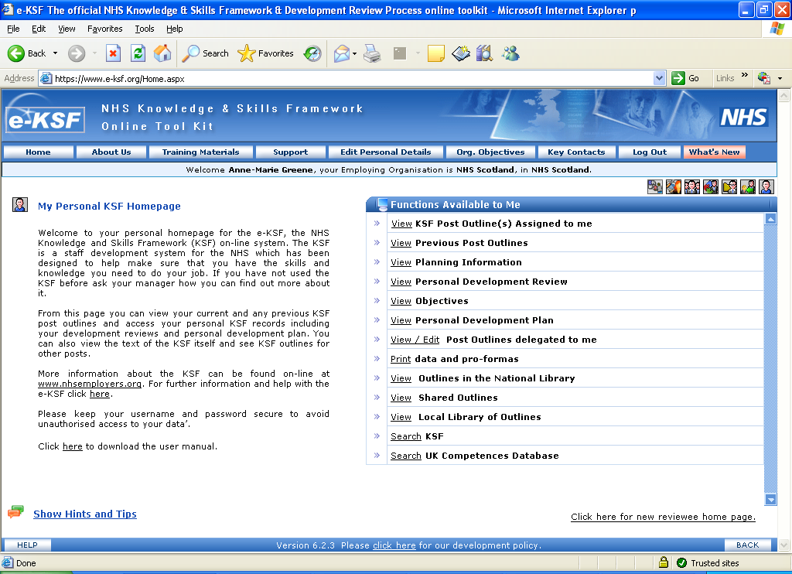

All of the options on this window are shown in a list and can be accessed by clicking on the underlined word at the start of each option. The options that you cannot access via the ‘new reviewee’ homepage layout are:
- Any alerts set by your local e-KSF Administrator that would appear under an additional option headed ‘View My Alerts’.
- The libraries of post outlines
- Any outlines that your Manager may delegate to you for checking whilst they are in draft.
To return to the previous homepage layout you need to click on the linked titled ‘click here for new reviewee homepage’ as shown on the previous page.
Some hints and tips on using e-KSF are shown on the following page.

Hints and Tips on using e-KSF

- e-KSF is a database that can be accessed anywhere that an internet connection is available. It can only be accessed using Internet Explorer.
- e-KSF is the tool for recording the outcome of discussions on the KSF processes between staff and their Manager/Reviewer. When recording the detail keep it simple by only recording the highlights of the discussion.
- It is not possible to record a review if a post outline has not been assigned to a staff member in e-KSF.
- The evidence window within a review document has a minimum number of characters that must be entered and this number is 3. The maximum is 8,000.
- Once a PDP activity has been completed it is possible to link this to the relevant dimension via the evidence window in an editable review document.
- It is possible for Reviewers and staff to upload files to Reviews and PDP’s. There is a 1MB limit per Review and the same limit covering all PDP activities.
- No matter what level of access you have for e-KSF if there is any underlined text showing on the screen you can click on this and it is a link to further information. For example the link to a review or objectives document is underlined.
- If any updates are made to e-KSF you can click on the pink ‘What’s new’ button at the top of your screen and this will list the details of the updates made.
- The ‘Edit Personal details’ button at the top of your screen opens a pop up window which allows you to view your personal information that has been received from SWISS; you can update your email address and phone numbers; you can reset your secret question and answer plus your login name; you can also change your password through this window.

Your local e-KSF Administrator will be able to provide you with further information on using the options available on your Staff homepage.

e-KSF Troubleshooting FAQ’s

- I have opened a review document for a staff member from my Manager homepage but I cannot add/save any information. Why is that?
If accessing a review from the Manager homepage you can only add ‘Manager comments’ to an editable document. You cannot update any other part of the review unless you access it from your Reviewer homepage.

- I cannot save any information to a review document that I have opened from my Reviewer page as there are no ‘save’ buttons. Why is that?
If you are in a review, objectives or PDP for a staff member via your Reviewer homepage and do not have any ‘save’ buttons then this is most likely because you have delegated your Manager access to a Secretary which also means that your Reviewer access is also delegated. If you are not a Manager and cannot see any ‘Save’ buttons please contact your local e-KSF Administrator.

- If I am having problems with e-KSF can I ask my IT department to fix it?
Your first contact point should you have any problems/issues with e-KSF is your local e-KSF Administrator and not your IT department. You can find the contact details for your e-KSF Administrator via the ‘Key Contacts’ button on e-KSF. Their details are under Employing Organisation Admin.

- Where do queries sent through the Support tab on e-KSF go to?
Any queries raised via the Support tab on e-KSF are sent to e-KSF Support and not your local e-KSF Administrator. Always contact your local Administrator with any problems/issues in the first instance

- When I click on the ‘Edit Personal Details’ button nothing happens. Why is this?
When you click on the ‘Edit Personal details’ button another window should ‘pop up’ on screen for you to check and update any relevant data. As this is not appearing it is most likely because your pop up blocker is switched on and it will not allow pop ups to appear. Please note that there are a lot of pop up windows within e-KSF so you need to switch off your pop up blocker.

To switch off your pop up blocker you need to go to ‘Tools’ on your Internet Explorer window and from the drop down menu select ‘Pop Up Blocker’. A menu will then appear at the side and you need to select ‘Turn off pop up blocker’. Once you have done this pop up windows will then open for you.

- How will my PDP show in e-KSF as I have two jobs?
You will only see one PDP document no matter how many jobs you have at your Board. If you have a different Manager/Reviewer for each post they will only see the PDP for the job that they are responsible for in relation to KSF.

Your local e-KSF Administrator will be able to provide you with further information on using e-KSF.

Case Studies

NHS Fife Case Study
Title: Realising the benefits of implementing KSF within an acute hospitals Physiotherapy Department
The Organisation
NHS Fife provides healthcare to a population of 360,000 people in a diverse rural and urban area of 507 square miles. We are the second largest employer in Fife with 8600 full and part-time employees.
What we did and why
In 2008 the Scottish Government included a workforce based national performance target within the national NHS performance framework – Health, Efficiency, Access and Treatment (HEAT) targets. This target required all NHS Boards in Scotland to ensure that staff employed under Agenda for Change terms and conditions had a KSF based Personal Development Plan (PDP) by the end of March 2009. NHS Fife as an organisation was committed to achieving this target and the physiotherapy department wanted to ensure that all physiotherapy staff had a KSF post outline and PDP by the target date supporting the full implementation of KSF.
How we did it
We worked collaboratively with colleagues in primary care and with all grades of staff to develop local KSF post outlines. Our local e-ksf administrator provided support to ensure that all KSF post outlines were completed on the e-ksf tool. All staff were supported to attend the in-house KSF training programme. Managers from the departments provided presentations and offered ½ day workshops for senior clinicians in order to ensure a full understanding of the KSF and development review process. In addition managers fully supported those training needs which had been identified within a KSF PDP.
The Results and Next Steps
We found that the process of producing the KSF post outlines helped us focus on the core responsibilities within posts and as a result we were able to reduce the number of different job descriptions across the department and lessen the considerable variation across these. In addition staff found that the KSF processes were helpful in helping them focus on evidence requirements for a development review and were also able to be clear on their CPD requirements. A further benefit was that they felt much more prepared for the HPC re-registration process.
Contact Details
Evelyn O'Neil
KSF Manager
Organisation Development & Learning Department
NHS Fife
Direct Line: 01592 226530
eoneil@nhs.net

NHS Grampian Case Study
Case Study Title ; Implementing KSF and eKSF within the Facilities Directorate
The Organisation
Grampian NHS Board is responsible for improving the health of the Grampian population, and for delivering the health care required.
The Grampian region has population of half-a-million people spread over 3,000 square miles of city, town, village and rural communities.
What we did and why
During the process of implementing KSF throughout the organisation it became apparent that it would be difficult to introduce the electronic tool to this group of staff in the first instance. This was due to the lack of access to IT equipment for these staff groups and the low level of Basic IT skills. We also took into account the number of staff each reviewer would have to review. Agreement was reached in partnership to allow this group of staff to complete reviews on paper as the first phase of implementation.
Thereafter we planned a staged approach to implementation during which we would address basic IT requirements, access to PC’s and moving eventually towards recording reviews electronically on e-ksf by job families.

How we did it
We made contact with managers in the service asking them to provide the KSF Team with names of staff to be entered on to their manager pages on e-ksf.
Managers then assigned appropriate KSF post outlines to staff with support from KSF Team.
The eKSF Administrator activated the ‘compete on paper’ option on eKSF for all of the managers in this project.
As staff had their development review discussions with managers, these were signed off as completed on paper with agreement from both parties.
Paper templates were developed for each job family e.g. Domestic, Porter, Catering Assistant which match pages on e-ksf and provide the relevant details from the KSF post outline.
Packs were then compiled which included a copy of the KSF post outline, a paper template for their review preparation and discussion, an e-ksf user guide and contact details for local support.
Awareness sessions were held for managers/reviewers on completion of the paper template.
Roadshows were held for staff to deliver KSF awareness sessions including the electronic tool and how to complete the paper evidence linking with their KSF Outline.

There were some key lessons learned during the process
We would not have been able to achieve this within the agreed timescales if there was no dedicated resource for the project.
We would deliver more awareness sessions for managers/reviewers before starting the Roadshows for staff
Providing support from the KSF team to managers is critical. Everyone in the team has a key role to play to support implementation.

The Results and Next Steps
To date approx 150 staff have attended the roadshows which will continue into next year.
We plan to continue to deliver the Roadshows up until March 2010. The Training and Development Manager will look at auditing this process with a group in the future. When this process is imbedded then we plan to progress towards full electronic recording of reviews on a phased basis with each job family.

Information on providing supplementary materials
Copies of the templates are available on request.
Contact Details
Helen Cheyne
KSF Project Manager
Learning and Development Department
NHS Grampian
Direct Line: 01224 556235
helen.cheyne@nhs.net

FACILITIES DIRECTORATE

ANNUAL KSF & DEVELOPMENT REVIEW

Post: Domestic Assistant (Band 2)

Employee Name | Manager/Supervisor
Date of Review: | Site:

Purpose of the Review:

Your Performance and Development Review gives you the opportunity to discuss your :-

- Performance at work
- Personal development needs
- Objectives over the coming year

This formal review is part of the ongoing process, which provides honest feedback and encourages self-assessment.

How to Prepare:

In order to get full benefit and ensure that an effective review takes place it is important that you take time to prepare for the meeting beforehand.

In order for you to get the most out of this review meeting it would be helpful if you could complete this form and bring it along to your review meeting with your Supervisor / Manager. Your comments can often be very helpful, and can help discussion.

- How does the work you do help the staff, visitors or the patients who are receiving care in your hospital / clinic?

- What parts of your current role do you :-

(a) Most enjoy (b) Least enjoy

- What situations at work have you dealt with particularly well over the last 12 months

- In what areas of work do difficulties sometimes arise?

- What do you think can be done about them?

- What training have you received since your last KSF & Development Review meeting and how did this effect the way you carry out your job?

- What experience or training do you think would help you carry out your job more effectively?

- Do you have any skills and experience that you are not using in your current job role?

- Are you interested in working in other areas?

Employee Name: | Manager / Supervisor: |  | Foundation Gateway
Date: | Base:
Period of Current Review: | Date of Previous Review: |  | 2nd Gateway

Reviewers please note indicators relating to development to be met at Foundation Gateway level have been indicated by ‘ ✓ ’

C1 - Communication – Level 1
 | The worker; | 2nd  Gateway | Foundat. Gateway | Evidence Found / Comments
a | Communicates with a limited range of people on day-to-day matters in a form that is appropriate to them and the situation |  | ✓
b | Reduces barriers to effective communication |  | ✓
c | Presents a positive image of her / himself and the service |  | ✓
d | Accurately reports and / or records work activities according to organisational procedures |  | ✓
e | Communicates information only to those people who have the right and need to need to know it consistent with legislation, policies and procedures |  | ✓

C2 – Personal & People Development – Level 1
 |  | 2nd  Gateway | Foundat. Gateway | Evidence Found / Comments
a | With the help of others, identifies:  - whether s/he can carry out the tasks within own job  - what s/he needs to learn to do current job better  - when s/he needs help |  | ✓
b | Reviews his / her work against the KSF outline for his / her post with his / her reviewer and identifies own learning needs and interests
c | Produces with his / her reviewer a personal development plan |  | ✓
d | Takes an active part in agreed learning activities and keeps a record of them
e | Evaluates the effectiveness of learning activities for own development and the job

C3 – Health, Safety & Security – Level 1
 |  | 2nd  Gateway | Foundat. Gateway | Evidence Found / Comments
a | Acts in ways that are consistent with legislation, policies and procedures for maintaining own and others health, safety and security |  | ✓
b | Assists in maintaining a healthy, safe and secure working environment for everyone who is in contact with the organisation |  | ✓
c | Works in a way that minimises risks to health, safety and security |  | ✓
d | Summonds immediate help for any emergency and takes the appropriate action to contain it |  | ✓
e | Reports any issues at work that may put health, sfaety and security at risk |  | ✓

C4 – Service Improvement – Level 1
 |  | 2nd  Gateway | Foundat. Gateway | Evidence Found / Comments
a | Discusses with line manager / work team the changes that need to be made in own practice and the reasons for them |  | ✓
b | Adapts own practice as agreed and to time seeking support if necessary |  | ✓
c | Effectively carries out tasks relating to evaluating services when asked |  | ✓
d | Passes on to the appropriate person constructive views and ideas on improving services for users of the public |  | ✓
e | Alerts line manager / work team when direction, policies and strategies are adversley affecting users of services or the public |  | ✓

C5 – Quality – Level 2
 |  | 2nd  Gateway | Foundat. Gateway | Evidence Found / Comments
a | Acts consistently with with legislation, policies, procedures and other quality approaches and encourages others to do so |  | ✓
b | Works within the limits of own competence and levels of responsibility and accountability in the work team and organisation |  | ✓
c | Works as an effective and responsible team member |  | ✓
d | Prioritises own workload and organises own work to meet these priorities and reduce risks to quality |  | ✓
e | Uses and maintains resources efficiently and effectively and encourages others to do so |  | ✓
e | Monitors the quality of work in own area and alerts others to do so |  | ✓

C6 – Equality & Diversity – Level 1
 |  | 2nd  Gateway | Foundat. Gateway | Evidence Found / Comments
a | Acts in ways that are in accordance with legislation, policies and procedures and good practice |  | ✓
b | Treats everyone with whom they come into contact with dignity and respect |  | ✓
c | Acknowledges others’ different perspectives |  | ✓
d | Recognises that people are different and makes sure they do not discriminate against people |  | ✓
e | Recognises and reports behaviour that undermines equality and diversity |  | ✓

HWB10 – Products to meet health and wellbeing needs – Level 1 *
 |  | 2nd  Gateway | Foundat. Gateway | Evidence Found / Comments
a | Checks with relevant information sources to confirm the preparation tasks to be undertaken |  | ✓
b | Prepares and uses equipment and work areas correctly in line with established procedures |  | ✓
c | Obtains the correct amount and type of products and ingredients and confirms their quality |  | ✓
d | Prepares simple products and ingredients according to instructions and in a way which;  - maintains their quality  - is consistent with legislation, policies and procedures  - minimises risks to staff, others and the work environment |  | ✓
e | Confirms that prepared items meet requirements, places them in the correct conditions and location for the next stage of use, together with any required labels, information and sundries |  | ✓
f | Identifies and reports any problems with ingredients, products, preparation equipment or work areas |  | ✓
g | Cleans and restores equipment and work areas, leaving them in a suitable condition for future use |  | ✓

* May only be applicable to some members of staff

EF2 – Environments and buildings – Level 1
 |  | 2nd  Gateway | Foundat. Gateway | Evidence Found / Comments
a | Follows schedules and procedures for assisting with maintainance and monitoring |  | ✓
b | Correctly and safely prepares, uses, cleans and stores equipment, tools and materials |  | ✓
c | Prepares work areas correctly and leaves them clean and safe after use |  | ✓
d | Carries out maintenance and monitoring tasks effectively and in a way which;  - causes minimum disruption to users  - minimises risks to self, others and the work environment  - is consistent with relevant legislation, policies and procedures |  | ✓
e | Reports any problems to the appropriate person without delay |  | ✓

Personal / Training & Development Plan (this information is required to be transferred onto the eKSF system)
 |  | Elementary Food Hygiene Certificate |  |  |  | Moving & Handling |  |  |  | Facilities Directorate - Corporate Induction Woorkbook (Purple)
 |  | Annual Fire Training |  |  |  | CPR |  |  |  | Infection Control Awareness
 |  | Violence & Aggression (Level 1) |  |  |  | Domestic Assistant Workbook (Green) |  |  |  | COSHH
 |  | Clincal Waste / Environmental Awareness |  |  |  | Local Induction Programme |  |  |  | Basic Health & Safety Awareness

Supervisor / Manager Comments (including any further Personal Development Needs)
Supervisor / Manager Signature: | Date:

Employee Comments
Employee Signature: | Date:

NHS Greater Glasgow & Clyde Case Study
Title: Support for Managers to Prepare for, Carry out and record Review Meetings
The Organisation – NHS Greater Glasgow and Clyde (NHSGGC)
NHSGGC serves a population of 1.2 million, employs over 44,000 staff and provides health services from 35 different hospitals, over 50 health centres and clinics and through 10 community health partnerships.
What we did and why
The focus up to and including March ’09 had been on ensuring all staff had a KSF based PDP in place. Although the training for Managers provided at that time included preparing, conducting and following up the Review meeting, there was inevitably a time gap between then and actually conducting a meeting. It became evident that some sort of short, simple step by step approach would be a helpful reference tool for Managers.
How we did it
A “Summary Information Sheet” was devised and made available via Staffnet (intranet) with live links to provide access to additional supporting materials. In addition, further information on recording evidence was included to ensure focus of the meeting was maintained. The mnemonic DOVE (documentary, observed, verbal and electronic) is suggested as an approach to recording the evidence and is included in the step by step guide.
This checklist is included as part of the on-going KSF PDP&R training for Managers. It is used as an integral part of the course material and provides both direction and summary information.
All supporting material is readily accessible and re-enforces the importance of ensuring that the main focus of the meeting is the discussion. Although preparation and follow up is required, this Guide breaks the process down into more manageable steps.
Access to intranet/internet is vital as there are links to supporting information. Papers copies can be made available through established internal communication routes however this results in many pages of text as opposed to the two pages that constitute the summary information. This is also an effective discussion document as increasing number of requests are received from management teams across NHSGGC for someone to provide up to date and refresher guidance on conducting the review meetings.
The Results and Next Steps
The short, simple concise language of the Guide along with the suggested approach to recording evidence has helped to ensure that the mainstreaming of KSF continues with a focus firmly on joint review, discussion and commitment to agreeing personal development plans as opposed to unnecessary time and energy spent on filling in the review document.
Contact Details
June Livingstone
KSF Manager
NHSSGGC
Direct Line: 0141 201 4718
June.livingstone@ggc.scot.nhs.uk

KSF/ PDP and R – Conducting the Review Meeting – May 2009
Summary Information for Managers / Reviewers

NHSGGC have returned 96.2% compliance with the March ’09 HEAT target of all staff having an agreed KSF based PDP in place.

KSF continues to be a major focus for all NHS Boards and there are three main priorities for Managers/ Reviewers:
- Ensuring KSF based PDPs are discussed and agreed for remaining staff (3.8%).
- Conducting reviews for all staff in line with their incremental dates
- Recording all PDP and R activity on e-KSF (in accordance with March 2011 HEAT target)
This information sheet has been developed as a reminder of the main steps.
Preparation for Review Meetings
- Check the incremental dates for your staff members on e-KSF and arrange review dates accordingly, (the dates can be checked on e-KSF as soon as the Outlines are assigned to individuals via “View Reports” on your Manager page) - contact e-KSF help team for assistance.
- Use the Ready Reckoner (Appendix 1 for Abridged Version, for Full Version (Excel File) contact the e-KSF Team) to schedule the review meetings. - see contact details for help/advice.
- Ensure that individuals have access to “Preparing for your Review” – (Appendix 2)
- Prepare for each individual review meeting by considering the current PDP, gathering information on the individuals work in relation to the KSF Outline (Evidence –see overleaf) and considering possible development needs and opportunities for next 12 months.
At the Meeting

The purpose of the PDP and R meeting is to:
- review progress with previously agreed Personal Development Plan and evaluate learning
- go through KSF Outline and review evidence provided/ discussed
- agree on-going and emerging development needs.
- record main points of discussion/ evidence (see overleaf and encourage post holder to record PDP.
There is no set format for the meeting, however, feedback to date suggests the following approach works well:
- As part of preparation, consider the current PDP and note which Dimension each activity relates to
- Conduct the meeting by working through each Dimension in turn and reviewing any current PDP activity as an integral part of the discussion (e.g if the individual had an agreed development activity to attend a series of meetings then that could be reviewed as part of the discussion on Core 1 - Communication).
- As each Dimension and indicator is worked through, the evidence provided by both post-holder and reviewer is discussed/ viewed and noted. Any resulting development needs for the next 12 months are to be recorded by the post holder or Reviewer on the PDP template (see overleaf)
- Agree date for PDP progress meeting (6 months time)
Evidence

Evidence can take many forms however must meet the following criteria:
- there must be sufficiency of evidence
- it must be up to date and relevant
- the same piece of evidence can be applicable to more than one Dimension and indicator
- it must be naturally occurring (not produced specifically for the review meeting).
The main forms of evidence fall into the category of:
- Documentary - e.g. report produced, set of minutes of meeting to either evidence attendance or production of Minutes, signed checklist etc
- Observed – e.g. – delivering a presentation, administering IV drugs, assisting a patient with dressing, using appropriate tools/devices etc
- Verbal – e.g. – discussion on skills of breaking bad news, dealing with emergency situations, identifying and taking action when Equality and Diversity issues are undermined etc
- Electronic – e.g. – spreadsheet created, e-mails produced etc
This mnemonic of DOVE may be helpful in recording the evidence provided from the PDP and R meeting – (see Annex B for different examples of how evidence may be recorded, it must be noted that these are examples only, are not intended to be prescriptive and are recorded on the original version of the paperwork)
Paperwork
It is recommended that the discussion at the Review meeting is captured on paper and transferred to e-KSF as soon as possible. There are two versions available for use:
- The original version which was used on Module 2 training over the last 3 years
- An updated version which mirrors e-KSF more closely and which is used on the current revised KSF PDP/e-KSF training for Managers/ reviewers. (Appendix 3).
Please note that the information recorded is very similar in both versions, just in a slightly different format and either can be used. The outcomes of the meeting can be recorded directly onto e-KSF but feedback to date suggests that paper based note-taking in the first instance is preferable.
New Staff
- All employees, as part of the Induction process, must meet with their Manager/Reviewer within the first few weeks of starting to discuss the KSF Foundation Outline and identify and agree priority development needs for the first 12 months in post.
- 6 month PDP progress meeting must be arranged to ensure that individual is on target to meet requirements of Foundation Outline.

e-KSF
As work towards full electronic recording, the following must be carried out:
- Everyone to obtain e-KSF user name and password. (by email to eksf@ggc.scot.nhs.uk)
- Managers to forward staff lists to e-KSF Team (spreadsheet from eksf@ggc.scot.nhs.uk)
- Managers to electronically assign KSF Outline to all staff in their area.(for telephone support, contact the e-KSF help team)
- Access training either via an identified expert user in your area, by attending a small group hands on session or through one to one support from the e-KSF help team
- Conduct the review meeting, record outcomes on paper (although as stated overleaf, it is possible to record straight onto e-KSF – for advice, please contact Ishbel Whitters) and then enter details onto e-KSF. This can be done by either the post-holder, the Manager/Reviewer or delegated individual.
- Both post-holder and Manager/Reviewer sign off the content by password.

For help with all aspects of KSF including incremental dates, evidence and conducting the review meeting, please contact:

June Livingstone – 0141-201-4718 June.Livingstone@ggc.scot.nhs.uk
(KSF Manager)
Marion Henderson – 0141-201-1292 Marion.Henderson@ggc.scot.nhs.uk
(Learning and Education Adviser – Acute Services)

For help with any aspect of e-KSF including user names, passwords, transferring information onto e-KSF, training support etc, please contact:

e-KSF Help Desk – 0141-201-0022/ 0141-201-0482 eksf@ggc.scot.nhs.uk

Ishbel Whitters – 0141-201-0769 Ishbel.Whitters@ggc.scot.nhs.uk
(e-KSF Manager)

To discuss any aspect of KSF with a Trade Union representative, either contact your own steward directly or contact :

Ross McCulloch – 0141-276-3710 Ross.McCulloch@glasgow.gov.uk
(KSF Staff Side Adviser)
NHS KNOWLEDGE AND SKILLS FRAMEWORK (KSF)

Summary of meeting outcomes for entry on e-KSF

Name |  |  |  | Job Title
Post Outline Title |  |  |  | Name of Reviewer
Department |  |  | Meeting Dates
Location |  |  | Personal Development Review Discussion
Review Period | From |  | PDP Creation (Agreed)
Review Period | To |  | PDP Progress Meeting (6 months)

NHS KSF Dimensions  CORE | Levels |  |  |  |  | Evidence for Decision/Comments
NHS KSF Dimensions  CORE | Foundation |  | Full | Current |  | Evidence for Decision/Comments
- Communication | 2 |  | 3 | 2 |  | This is an example of using the DOVE mnemonic with highlighted development need  - Documentary – case file, minutes of CP meeting, completed SOSA form  - Observation – Presenting research findings, meeting with service users, providing feedback to team members  - Verbal/Discussed – Understanding and application of current CP legislation, preparing and following up bad news meetings  - Electronic – Current caseload database, emails to external agencies, input to SSTS  Identified development need in dealing with patient emotions in bad news meetings. (Indicator b).
- Personal and People Development | 2 |  | 2 | 2 |  | This is an example of using text only to record a brief summary of the discussion that took place  Mary’s experience and commitment to her own development as well as others is evident and observed through her daily work. She is also active in identifying on-going and emerging development needs.  She has an active role in orientating new members of staff to daily work schedules and this is evidenced by feedback with examples and thank you notes from new members of staff.
- Health, Safety and Security | 2 |  | 2 | 1 |  | This is an example of listing the evidence and cross referring it to the indicators  Fire Drill records (d) (f)  Minutes of local H&S meetings (a) (e)  Verbal Discussion (a) (b) (f)  Observation (c )  Risk Assessment forms (a) (b)  Indicator (e) – identified development need to develop greater understanding, purpose, documentation format and follow up actions required for incident reporting.
NHS KSF dimensions  SPECIFIC(S) | Levels |  |  |  |  | Evidence for Decision/Comments
- Service Improvement | 2 | 2 |  |  | 2 | This is an example of using part of the DOVE mnemonic to record evidence along with confirmation of no development need.  - D- evaluated information on patient admission procedure, completed staff survey, minutes of Quality Improvement Meeting, action notes from team meetings  - O- implemented change to patient meal times on feedback from relatives, feedback to team on current initiatives  - V- discussion at meeting on implications of “Time to Care” and “ NHS Quality Strategy”  No identified development need for the next 12 months.
- Quality | 2 | 2 |  |  | 1 | This is an example of listing the evidence as it applies to each indicator  a) discussion on current policies and procedures and ensures team members understanding and application  b) works according to documented and agreed objectives  c) acts as role model within own team (observed and feedback from others)  *d) self assessed development need  e) all orders are placed in a timely and effective manner in accordance with set procedures -indents and purchase orders support this.  f) internal audit conducted on service user satisfaction with results implemented and monitored  *Identified need to understand the importance and benefits of forward planning and working in an organised environment.
- Equality and Diversity | 2 | 2 |  |  | 2 | This is an example of using DOVE with an agreed development opportunity noted  D –Developed patient information leaflets for ward,  O- Took action and reported incident when colleague’s expressed beliefs undermined, works within multi-cultural team  V- Discussion on practice of treating individuals in accordance with their expressed Faith in relation to privacy and dignity, feedback from service users  E- Maintains excel spreadsheet of current and emerging policies with E and D implications  No development need identified, however keen to further develop knowledge and understanding of E&D issues. Following discussion agreed that personal interest may be enhanced by sourcing and attending appropriate internal training. (To be discussed and agreed with line manager at time of booking).

Appendix 1


Bringing current KSF PDP dates into line with incremental dates

This “Ready Reckoner” is designed to assist with bringing an individual’s current annual review date in line with their incremental date. This will mean that the current review period may be slightly compressed or extended for some individuals. This will depend on when the initial meeting took place and therefore when the next review is due to take place.
Reports show that the bulk of activity in terms of discussing and agreeing KSF based PDPs took place in March, May, June, November and December. This should mean that Managers have time to work this into their current review plans. (please don’t hesitate to contact any of the KSF Team for help)
A full and detailed ready reckoner is available on the KSF page of Staffnet however, this abridged version will be sufficient in the majority of cases.

Incremental month | KSF PDP review cycle  Earliest - latest
Jan | 1 Jul - 15 Nov
Feb | 1 Aug - 15 Dec
Mar | 1 Sep - 15 Jan
Aprl | 1 Oct - 15 Feb
May | 1 Nov - 15 Mar
Jun | 1 Dec - 15 Apr
Jul | 1 Jan - 15 May
Aug | 1 Feb - 15 Jun
Sep | 1 Mar - 15 Jul
Oct | 1 Apr - 15 Aug
Nov | 1 May - 15 Sep
Dec | 1 Jun - 15 Oct

Appendix 2

KSF/PERSONAL DEVELOPMENT PLANNING & REVIEW PREPARATION

Your KSF based Personal Development Plan will evolve through a discussion with your Reviewer. This document may help you prepare for the meeting. It is for personal preparation only.

- Make sure you have a copy of your current Job Description & KSF Outline.
- Consider the Job Description/KSF Outline and highlight the areas where you have achieved the Dimensions at the relevant levels. Note the evidence that you will take along/ discuss at the review meeting.
- Consider any other/additional areas of activity that you have been involved in over the year. i.e. working groups, projects etc. and how they may fit with your KSF Outline and provide evidence.
- Again consider your Job Description/KSF Outline and highlight the areas where you may not yet have met the Dimensions and Indicators. Take a note of these and consider why you could not meet them. Think about how they could be met in the future i.e. development or support needed.
- Consider further development needs that you may have in relation to the needs of your Job Description/KSF Outline. Think about how these could be met and support required.
- Consider any further development needs that you may have in relation to career plans and be ready to discuss them with your reviewer.
- Consider any additional areas you would like to discuss.

Appendix 3

NHS KNOWLEDGE AND SKILLS FRAMEWORK (KSF)

Format for recording meeting outcomes for entry on e-KSF

Name |  |  |  |  |  |  |  | Job Title
Post Outline Title |  |  |  |  |  |  |  | Name of Reviewer
Department |  |  |  |  |  | Meeting Dates
Location |  |  |  |  |  | Personal Development Review Discussion
Review Period | From |  |  |  |  | PDP Creation (Agreed)
Review Period | To |  |  |  |  | PDP Progress Meeting (6 months)
NHS KSF Dimensions  CORE |  | Levels |  |  |  |  | Evidence for decision/Comments
 |  | Foundation |  | Full | Current
- Communication

- Personal and people development

- Health, safety and security

NHS KSF dimensions  SPECIFIC(S) |  | Levels |  |  |  |  | Evidence for decision/Comments
- Service improvement

- Quality

- Equality and diversity

NHS KSF dimensions  SPECIFIC(S) | Levels |  |  | Evidence for decision/Comments
NHS KSF dimensions  SPECIFIC(S) | Foundation | Full | Current | Evidence for decision/Comments

PERSONAL DEVELOPMENT PLAN
Target Completion Date | Learning Aim/Purpose | Activity  (What will I do) |  | Priority  (Drop Down Boxes) | (√)
 |  |  |  | Mandatory
 |  |  |  | Essential to role
 |  |  |  | Desirable for Organisation
 |  |  |  | Desirable for individual
(Drop down boxes) More Detail (Optional)
How will I know this activity has been effective?
Who or what can help me with this activity?
How can I get that help?
Who or what might hinder me in this activity?
How can I overcome these barriers?
Linked Dimension(s):
NB Please make additional copies of this page as required
Evaluation of development

This pop up box appears on e-KSF when the status of an activity is changed to “completed”.

Activity &  Completion Date | Effective  Yes/No? | Comments about effectiveness | How will you apply this learning to your post? | Who else will you share this learning with?
SERVICE OBJECTIVES (optional)
Service Objective | Target Completion Date | Constraints identified | Action Plan & Evaluation Process | Status  (Drop down box:  Not achieved,  No longer applicable, Carried forward) | Comments

NHS Shetland Case Study

Title: Using the eKSF as a learning needs analysis tool and as a support for meeting the Health Professions Council (HPC) Continuing Professional Development (CPD) standards for Allied Health Professionals (AHPs) employed in NHS Shetland.
The Organisation
NHS Shetland employs around 750 staff and is responsible for the health of a population of 22000 people. It is an island community, with thirteen inhabited islands stretching over 100 miles from Muckle Flugga in the north to Fair Isle in the south. The largest town, Lerwick, has a population of approximately 7,500 people. NHS Shetland currently employs a total of 31 AHPs, support workers and administration staff representing the following groups: Dietetic, Occupational Therapy, Orthotics, Podiatry, Physiotherapy, Diagnostic Radiography and Speech and Language Therapy
What we did and why
A continuing professional development (CPD) needs analysis was carried out by the Practice based Education Facilitator (PEF) for Allied Health Professionals (AHPs) using e-KSF. As part of this NHS Education for Scotland (NES) funded programme the AHP PEF was tasked with supporting AHPs in their locality to meet the Health Professions Council’s (HPC) standards for CPD. A further NHS Shetland organisational goal was to ensure 100% of staff agreed and recorded their personal development plans (PDPs) using e-KSF in order to meet the Scottish Government performance target.
How we did it
Approval to undertake this study was sought and granted by the NHS Shetland Clinical Governance Department.
Workshops were provided for all AHP staff and managers by the Staff Development Department in NHS Shetland. This gave staff and managers an introduction to the eKSF tool and in particular the functionality which allowed the electronic recording of a PDP.
The reports function within eKSF was used to extract data from all recorded PDPs to identify the main training needs for AHPs and profession specific groups to allow planning of relevant and targeted development interventions. All PDPs were analysed and categorised e.g. mandatory, profession specific etc.
This was a project in which learning was central throughout. Staff learned in the workshops and in turn gave feedback to facilitators on suggested improvements. We all shared experiences – good and bad. The unwillingness of some members of staff to change was the biggest barrier to be overcome. Other difficulties were around access to IT and lack of time to record PDPs on the system. However the benefit of eKSF is that as it is a web based tool PDP activities can be added from any computer with internet access and that records can be updated over time.
Advice for other organisations would be to support training workshops with departmental champions who are available in the workplace to answer questions and support staff as they use the tool following training.
The Results and Next Steps
We were able to demonstrate to AHPs how the eKSF is used to record PDPs and could support them in meeting the HPC standards for CPD
- PDP’s are stored in date order and categorised by year
(standard 1)
- Details are provided on the development activity
(Standard 2)
- Provides evidence of learning e.g. reflections and actions
(Standard 3 &4)
- PDPs can be stored, saved and printed on request
(Standard 5)
- Evidence is provided that all work completed is that of the registrant
(standard 6)
By analysis and categorisation of all AHPs and PDPs, themes regarding education and training needs could be identified across AHPs as a group e.g. the need for clinical supervision training.
Relevant training interventions could be planned and offered facilitating best value in the use of training budgets and improving the effectiveness of the training provision.
NHS Shetland was supported to achieve the health, equality, access and treatment (HEAT) performance target of 100% of staff submitting PDPs using e-KSF
We are now working with staff, managers and reviewers in NHS Shetland to support the recording of joint development reviews on the eKSF.
We have submitted a Project Initiation Document (PID) to NHS Education Scotland (NES) seeking resource to develop a training and support package to
- equip the AHP PEFs across the NHS in Scotland with tools to identify and support the development requirements of AHPs.
- Support the AHP PEFs in developing an understanding of
- The application of eKSF as a learning needs analysis tool
- Access and undertake a CPD analysis
- How eKSF can support AHPs in meeting the HPC CPD standards and provide the relevant information required as part of the HPC audit process.
Contact information
Bruce McCulloch
Practice Based Education Facilitator for Allied Health Professionals
Direct Line: 01595-743-222
bruce.mcculloch@nhs.net

